ID: BC080400090
Name: Asif Ashraf
CS504 Fall 2016 Assignment 01

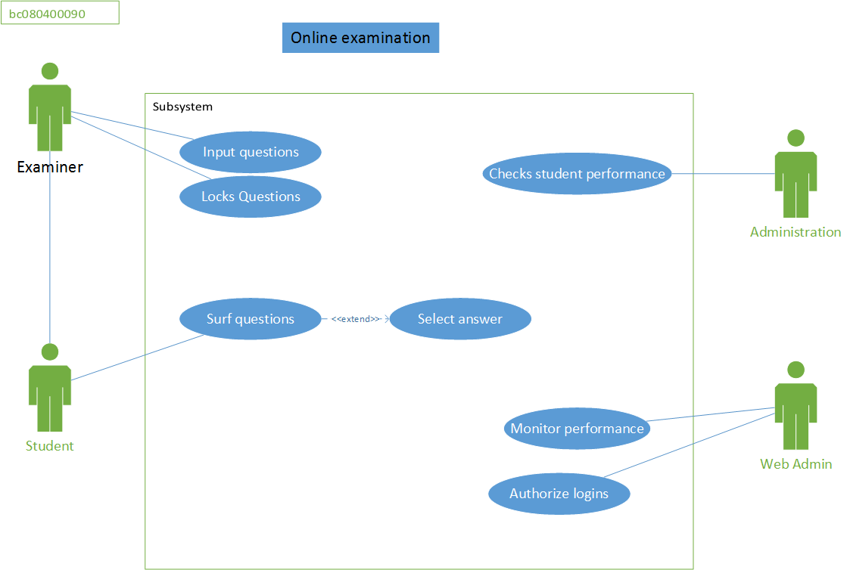
- Name of different Actors.
  - Examiner
  - Administration
  - Student
  - Web Admin
  - Optionally we can also show SYSTEM as actor because it was written that the system will automatically captures answers. Now I believe this will happen on user action, but system can also act if student doesn’t reply too quickly just like our Quiz. A little ambiguous situation for me.

- Alternatives path. (For Registration and Score Calculation)
- User friendly errors, such as validations
- Authorization failed/locked
- Student doesn’t attend exam

- Exceptions (For registration process)
  - Client side Validation errors
    - Email not valid
    - Email already exists
    - Username not valid
    - Username Taken
    - Password length too short or long
    - Password complexity
    - Length of fields
Usually we handle errors at one place either on client side or server side. So we should always try to handle errors on client IFF we have decided to choose client side validation. That is why I have written a few examples of validations on client side. And Emitting server side errors. If validations are handled nicely on client side then server side errors will be logical or design such as:
      - Database required field missing error
      - Other db field errors such as field format
      - Database connection closed or any server side errors
For use cases these are just general exceptions.

